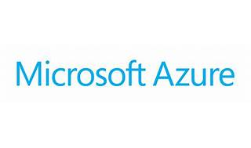



Explore

Certainly! In a nutshell, **Azure Cosmos DB** is a globally distributed, multi-model database service offered by Microsoft. [It’s designed to provide high availability, scalability, and low-latency access to data for modern applications, supporting both NoSQL and relational data models1](https://learn.microsoft.com/en-us/azure/cosmos-db/introduction)[2](https://en.wikipedia.org/wiki/Cosmos_DB).

Here are **five free learning resources** to help you explore Azure Cosmos DB:

1. [**Microsoft Learn: Introduction to Azure Cosmos DB**](https://learn.microsoft.com/en-us/azure/cosmos-db/introduction): Dive into the basics of Cosmos DB, understand its features, and learn how to use it effectively.
2. [**Coursera: Getting Started with Azure Cosmos DB**](https://www.coursera.org/projects/getting-started-with-azure-cosmos-db): Create Cosmos DB accounts, databases, containers, and learn about global distribution and data migration.
3. [**Microsoft Learn: Explore Fundamentals of Azure Cosmos DB**](https://learn.microsoft.com/en-us/training/modules/explore-non-relational-data-stores-azure/): Understand key features, supported APIs, and how to provision and use an Azure Cosmos DB instance.
4. [**Microsoft Learn: Quickstart - Create Azure Cosmos DB Resources**](https://learn.microsoft.com/en-us/azure/cosmos-db/nosql/quickstart-portal): Learn how to create databases, containers, and items using the Azure portal.
5. [**Microsoft Learn: Try Azure Cosmos DB Free**](https://learn.microsoft.com/en-us/azure/cosmos-db/try-free): Get hands-on experience with a 30-day free trial. No credit card required!

Feel free to explore these resources and enhance your knowledge of Azure Cosmos DB! 🌟🚀